Шарифулин Женя ПМИ-2-2022

Лабораторная работа 1 по дисциплине «Протоколы и интерфейсы Интернет»

|  |  |  |  |  |
| --- | --- | --- | --- | --- |
| ping с какого адреса | ping на какой адрес | Результат (+/-) | Потерянных пакетов | Среднее время, мс |
| 192.168.0.1 | 192.168.0.1 | + | 0 | 5 |
| 192.168.0.1 | 10.0.0.2 | + | 0 | 7 |
| 192.168.0.3 | 192.168.0.3 | + | 0 | 4 |
| 192.168.0.3 | 192.168.0.1 | + | 1 | 2 |

Результаты по заданиям:

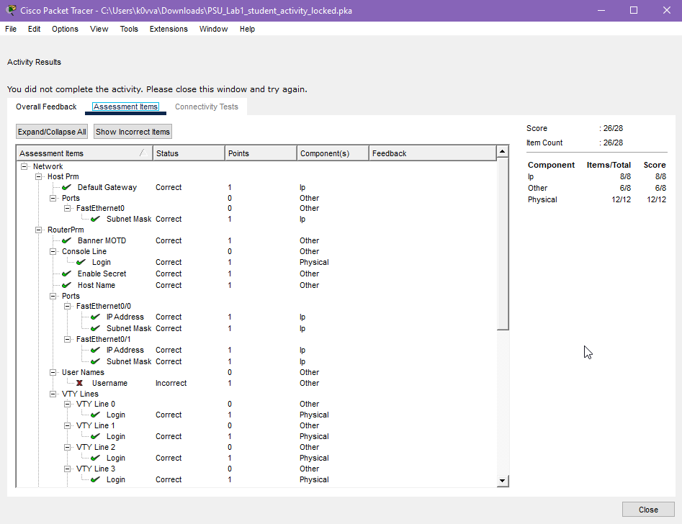

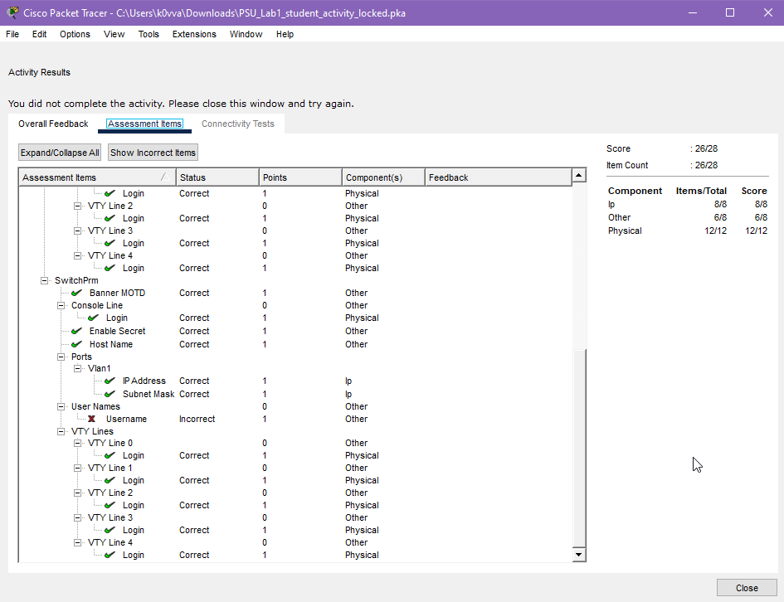

Конфигурация коммутатора:

RouterPrm#show running-config

Building configuration...

Current configuration : 776 bytes

!

version 12.4

no service timestamps log datetime msec

no service timestamps debug datetime msec

no service password-encryption

!

hostname RouterPrm

!

!

!

enable secret 5 $1$mERr$hx5rVt7rPNoS4wqbXKX7m0

!

!

!

!

!

!

ip cef

no ipv6 cef

!

!

!

username cisco password 0 cisco

!

!

!

!

!

!

!

!

!

!

spanning-tree mode pvst

!

!

!

!

!

!

interface FastEthernet0/0

description Link-to-Perm

ip address 10.0.0.2 255.255.255.0

duplex auto

speed auto

!

interface FastEthernet0/1

description Link-to-Perm

ip address 192.168.0.1 255.255.255.0

duplex auto

speed auto

!

interface Vlan1

no ip address

shutdown

!

ip classless

!

ip flow-export version 9

!

!

!

no cdp run

!

banner motd ^C Welcome home! ^C

!

!

!

!

!

line con 0

login local

!

line aux 0

!

line vty 0 4

login local

!

!

!

end

RouterPrm#show interface

FastEthernet0/0 is up, line protocol is up (connected)

Hardware is Lance, address is 00e0.8f12.1101 (bia 00e0.8f12.1101)

Description: Link-to-Perm

Internet address is 10.0.0.2/24

MTU 1500 bytes, BW 100000 Kbit, DLY 100 usec,

reliability 255/255, txload 1/255, rxload 1/255

Encapsulation ARPA, loopback not set

Full-duplex, 100Mb/s, media type is RJ45

ARP type: ARPA, ARP Timeout 04:00:00,

Last input 00:00:08, output 00:00:05, output hang never

Last clearing of "show interface" counters never

Input queue: 0/75/0 (size/max/drops); Total output drops: 0

Queueing strategy: fifo

Output queue :0/40 (size/max)

5 minute input rate 0 bits/sec, 0 packets/sec

5 minute output rate 0 bits/sec, 0 packets/sec

0 packets input, 0 bytes, 0 no buffer

Received 0 broadcasts, 0 runts, 0 giants, 0 throttles

0 input errors, 0 CRC, 0 frame, 0 overrun, 0 ignored, 0 abort

0 input packets with dribble condition detected

4 packets output, 184 bytes, 0 underruns

0 output errors, 0 collisions, 1 interface resets

0 babbles, 0 late collision, 0 deferred

0 lost carrier, 0 no carrier

0 output buffer failures, 0 output buffers swapped out

FastEthernet0/1 is up, line protocol is up (connected)

Hardware is Lance, address is 00e0.8f12.1102 (bia 00e0.8f12.1102)

Description: Link-to-Perm

Internet address is 192.168.0.1/24

MTU 1500 bytes, BW 100000 Kbit, DLY 100 usec,

reliability 255/255, txload 1/255, rxload 1/255

Encapsulation ARPA, loopback not set

Full-duplex, 100Mb/s, media type is RJ45

ARP type: ARPA, ARP Timeout 04:00:00,

Last input 00:00:08, output 00:00:05, output hang never

Last clearing of "show interface" counters never

Input queue: 0/75/0 (size/max/drops); Total output drops: 0

Queueing strategy: fifo

Output queue :0/40 (size/max)

5 minute input rate 4 bits/sec, 0 packets/sec

5 minute output rate 4 bits/sec, 0 packets/sec

4 packets input, 512 bytes, 0 no buffer

Received 0 broadcasts, 0 runts, 0 giants, 0 throttles

0 input errors, 0 CRC, 0 frame, 0 overrun, 0 ignored, 0 abort

0 input packets with dribble condition detected

8 packets output, 696 bytes, 0 underruns

0 output errors, 0 collisions, 1 interface resets

0 babbles, 0 late collision, 0 deferred

0 lost carrier, 0 no carrier

0 output buffer failures, 0 output buffers swapped out

Vlan1 is administratively down, line protocol is down

Hardware is CPU Interface, address is 0030.f237.a35c (bia 0030.f237.a35c)

MTU 1500 bytes, BW 100000 Kbit, DLY 1000000 usec,

reliability 255/255, txload 1/255, rxload 1/255

Encapsulation ARPA, loopback not set

ARP type: ARPA, ARP Timeout 04:00:00

Last input 21:40:21, output never, output hang never

Last clearing of "show interface" counters never

Input queue: 0/75/0/0 (size/max/drops/flushes); Total output drops: 0

Queueing strategy: fifo

Output queue: 0/40 (size/max)

5 minute input rate 0 bits/sec, 0 packets/sec

5 minute output rate 0 bits/sec, 0 packets/sec

1682 packets input, 530955 bytes, 0 no buffer

Received 0 broadcasts (0 IP multicast)

0 runts, 0 giants, 0 throttles

0 input errors, 0 CRC, 0 frame, 0 overrun, 0 ignored

563859 packets output, 0 bytes, 0 underruns

0 output errors, 23 interface resets

0 output buffer failures, 0 output buffers swapped out

RouterPrm#show ip interface brief

Interface IP-Address OK? Method Status Protocol

FastEthernet0/0 10.0.0.2 YES manual up up

FastEthernet0/1 192.168.0.1 YES manual up up

Vlan1 unassigned YES unset administratively down down

RouterPrm#show users

Line User Host(s) Idle Location

* 0 con 0 cisco idle 00:00:00

Interface User Mode Idle Peer Address

Конфигурация коммутатора

SwitchPrm#show running-config

Building configuration...

Current configuration : 1273 bytes

!

version 12.2

no service timestamps log datetime msec

no service timestamps debug datetime msec

no service password-encryption

!

hostname SwitchPrm

!

enable secret 5 $1$mERr$hx5rVt7rPNoS4wqbXKX7m0

!

!

!

!

username cisco privilege 1 password 0 cisco

!

!

!

spanning-tree mode pvst

spanning-tree extend system-id

!

interface FastEthernet0/1

!

interface FastEthernet0/2

!

interface FastEthernet0/3

!

interface FastEthernet0/4

!

interface FastEthernet0/5

!

interface FastEthernet0/6

!

interface FastEthernet0/7

!

interface FastEthernet0/8

!

interface FastEthernet0/9

!

interface FastEthernet0/10

!

interface FastEthernet0/11

!

interface FastEthernet0/12

!

interface FastEthernet0/13

!

interface FastEthernet0/14

!

interface FastEthernet0/15

!

interface FastEthernet0/16

!

interface FastEthernet0/17

!

interface FastEthernet0/18

!

interface FastEthernet0/19

!

interface FastEthernet0/20

!

interface FastEthernet0/21

!

interface FastEthernet0/22

!

interface FastEthernet0/23

!

interface FastEthernet0/24

!

interface GigabitEthernet0/1

!

interface GigabitEthernet0/2

!

interface Vlan1

ip address 192.168.0.3 255.255.255.0

!

ip default-gateway 192.168.0.1

!

banner motd ^C Welcome home! ^C

!

!

!

line con 0

login local

!

line vty 0 4

login local

line vty 5 15

login

!

!

!

!

end

SwitchPrm#show interface

FastEthernet0/1 is up, line protocol is up (connected)

Hardware is Lance, address is 0001.42c8.1101 (bia 0001.42c8.1101)

BW 100000 Kbit, DLY 1000 usec,

reliability 255/255, txload 1/255, rxload 1/255

Encapsulation ARPA, loopback not set

Keepalive set (10 sec)

Full-duplex, 100Mb/s

input flow-control is off, output flow-control is off

ARP type: ARPA, ARP Timeout 04:00:00

Last input 00:00:08, output 00:00:05, output hang never

Last clearing of "show interface" counters never

Input queue: 0/75/0/0 (size/max/drops/flushes); Total output drops: 0

Queueing strategy: fifo

Output queue :0/40 (size/max)

5 minute input rate 0 bits/sec, 0 packets/sec

5 minute output rate 0 bits/sec, 0 packets/sec

956 packets input, 193351 bytes, 0 no buffer

Received 956 broadcasts, 0 runts, 0 giants, 0 throttles

0 input errors, 0 CRC, 0 frame, 0 overrun, 0 ignored, 0 abort

0 watchdog, 0 multicast, 0 pause input

0 input packets with dribble condition detected

2357 packets output, 263570 bytes, 0 underruns

SwitchPrm#show ip interface brief

Interface IP-Address OK? Method Status Protocol

FastEthernet0/1 unassigned YES manual up up

FastEthernet0/2 unassigned YES manual up up

FastEthernet0/3 unassigned YES manual up up

FastEthernet0/4 unassigned YES manual down down

FastEthernet0/5 unassigned YES manual down down

FastEthernet0/6 unassigned YES manual down down

FastEthernet0/7 unassigned YES manual down down

FastEthernet0/8 unassigned YES manual down down

FastEthernet0/9 unassigned YES manual down down

FastEthernet0/10 unassigned YES manual down down

FastEthernet0/11 unassigned YES manual down down

FastEthernet0/12 unassigned YES manual down down

FastEthernet0/13 unassigned YES manual down down

FastEthernet0/14 unassigned YES manual down down

FastEthernet0/15 unassigned YES manual down down

FastEthernet0/16 unassigned YES manual down down

FastEthernet0/17 unassigned YES manual down down

FastEthernet0/18 unassigned YES manual down down

FastEthernet0/19 unassigned YES manual down down

FastEthernet0/20 unassigned YES manual down down

FastEthernet0/21 unassigned YES manual down down

SwitchPrm#show users

Line User Host(s) Idle Location

* 0 con 0 cisco idle 00:00:00

Interface User Mode Idle Peer Address